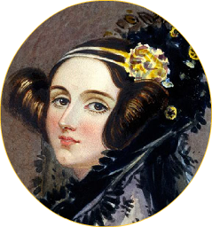
Without Women, computing as we know it would not EXIST!
The first computer programmer was a woman.

The inventor of Bluetooth and GPS technology
was a woman.
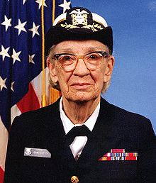
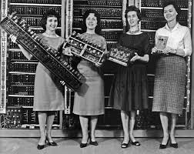
The team of programmers for the ENIAC computer were ALL women.

The inventor of the compiler was a woman.
The CEO of Hewlett-Packard is just one of the many women making a difference in computers today.

